A Report on Mini Project II.

On

# “HANDWRITTEN DIGIT RECOGNITION”

*Submitted in partial fulfillment of the requirements for the award of the degree of*

### Bachelor of Technology

*in*

COMPUTER SCIENCE & ENGINEERING

*by*

### Sutar Aditya A. 48

### Vadd Rohan R. 50

*Under the guidance of*

**Prof.S. J. Vibhute**

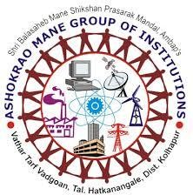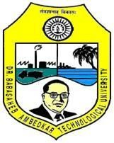

DEPARTMENTOFCOMPUTERSCIENCE&ENGINEERINGASHOKRAOMANEGROUPOFINSTITUTION,VATHAR

*AffiliatedTo*

DR.BABASAHEBAMBEDKARTECHNOLOGICALUNIVERSITY

Lonere-402103,Tal.Mangaon,Dist.Raigad(MS)INDIAA.Y.2023-24

# Certificate

The project report entitled **Handwritten Digit Recognition** submitted by **Aditya A. Sutar (2162171242023), Rohan R. Vadd (2162171242028)** is completed for the partial fulfillment of the requirement for the award of the degree of Bachelor of Technology in Computer Science & Engineering.

(Prof.S.J.Vibhute) ( Prof. S.S.Redekar)

Guide Head of Department

Computer Science & Engineering Computer Science & Engineering

(Prof.P.B.Ghewari) (Dr. A.V.Deshmukh)

VicePrincipal Principal

AMGOI,Vathar AMGOI,Vathar

**Acknowledgements**

Thisworkisjustnotanindividualcontributionuntilitscompletion.Itakethisopportunity to thank all for bringing it close to the conclusion. A special thanks goes to myGuide**Prof.S.J.Vibhute,**forleadingmetomanynewinsights,encouragingandteachingme how to get down to the root of the problem.

I am also grateful to **Prof. S.S.Redekar**and the department faculty and staff membersfor their assistance.

IamalsothankfultobelovedPrincipal**Prof.A.V.Deshmukh**&VicePrincipal**Prof.**

**P.B.Ghewari**forthekindsupport.

I am also thankful to all friends and well-wishers for support during the demandingperiod of this work. This document, in its eternity (as with everything I have or have yet toaccomplish) is attributable to the **Parents**, whose strength and compassion are my constantinspiration.

I would also like to thank our wonderful **Colleagues** and friends for listening to ourideas, asking questions and providing feedback and suggestions for improving our ideas.

Aditya A. Sutar

Rohan R. Vadd